The modification for No Load Shut Down (Green Function) for Blazer Series，
A：Regarding the unit used the PC Board which marked 098-08788-01/02 or 098-08714-XX, the modification is as below：
- Connect D1（1N4148），R1(44.2K OHM)，and R2(9.1K OHM) together，and soldering。
- And sold R1 to JP14; sold R2 to JP22; sold D1 to JP09。Please refer to the attached picture. 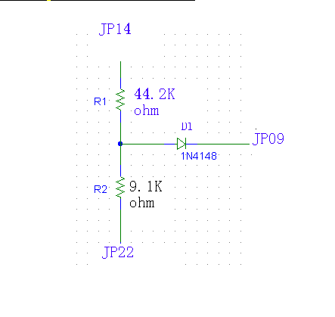
B：Regarding the unit used the PC Board which marked 098-08788-03, the modification is as below：
- Connect D1（1N4148），R1(44.2K OHM)，and R2(9.1K OHM) together，and soldering。
2. And solder R1 to JP14; solder R2 to JP42; solder D1 to JP06。Please refer to the attached picture.
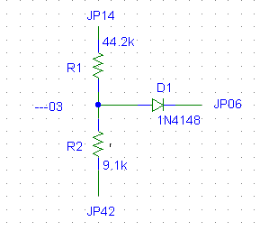

C：Regarding the unit used the PC Board which marked 098-18006-XX or 098-18018-XX, the modification is as below：
- Connect D1（1N4148），R1(44.2K OHM)，and R2(9.1K OHM) together，and soldering。
- And solder R1 to JP41; solder R2 to JP42; solder D1 to JP28。Please refer to the attached picture.
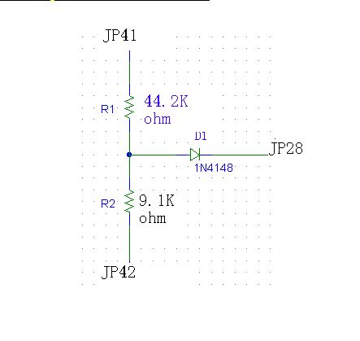
F：Regarding the unit used the PC Board which marked 098-08708-XX, the modification is as below：
- Connect D1（1N4148），R1(10K OHM)，and R2(4.7K OHM) together，and soldering。
2. And solder R1 to JP37; solder R2 to JP38; solder D1 to JP35。Please refer to the attached picture.
Note: this item is the modification for Blazer 1K and over models. In Nov, 2002, we have issued the ECN to cancel this function in the mass production.

